Analysis done across several states reveals some interesting trends as discussed in the following points:
- All the predictor variables, used in forecasting the HPI returns, showed a leading relationship with HPI. An interesting consequence of this is that the given model can effectively use the current information on these economic variables to predict the trends in housing price markets in the future. A direct business implication of this is that this model can be used to price assets, which can help in devising beneficial trading strategies, especially in the mortgage backed assets market.
- The percentage amount of explained variation attributed to each economic variable averaged over states is depicted in the pie chart below. The population size stands out as a prominent determinant of the trends in HPI returns with almost 50% of the explained variation being attributed to this single variable. Mortgage originations, unemployment rate and median income together explain another 40% of the explained variation. Since data for population and unemployment is readily and publicly available as compared to determinants like building permits and foreclosures, it’s a positive point in favor of the model that its explanatory power mostly lies in richer sources of information available.
These % contributions are determined by calculating the (SSR/SST) calculation for each predictor, where SSR = Sequential Sum of Regression (for the predictor) and SST = Sequential Sum Total, as obtained from the ANOVA output of the multiple linear regression model.

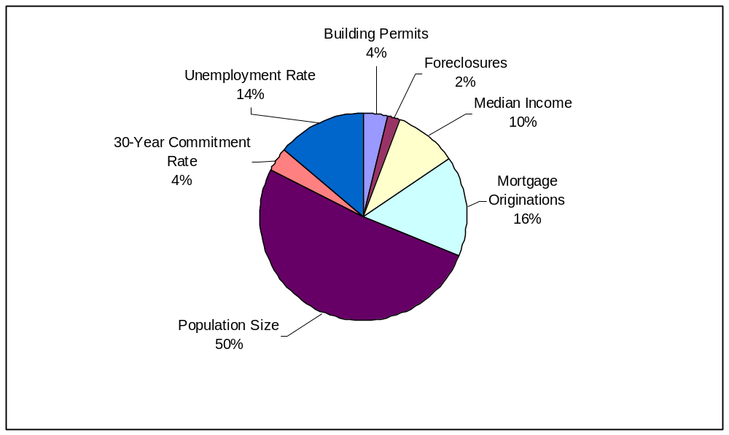

- Going further in understanding the distribution of average contribution of each variable by region across United States, we see that population size remains the most important determinant followed by a close contest between mortgage origination and unemployment rate for the next spot. However it can be seen that in the flatland region population weighs more than it does in the coastal regions, which are generally more densely populated. However for the middle states median income and mortgage originations tend to have a greater role to play as compared to their contribution to explaining the HPI returns in the coastal states. This could be understood in the following manner. In the middle states the population density is lesser as compared to the coastal states and they also have an abundant supply of land for the construction of new houses, this makes the houses more affordable due to limited demand and greater supply. This implies that demand variable such as population drives the housing prices more in these regions, as compared to coastal areas where land is scarce and population density is higher. High population density coupled with greater demand also causes mortgage originations to have a considerable contribution to explaining the overall variation.

